**Caching in Name Data Vehicular Sensor Network**

*Mini Project Synopsis Report*



*Submitted by:*

**Sudipta Dey (201600448)**

**Mohit Rathor (201600412)**

**Prantik Dey(201600402)**

*Under the supervision of:*

**Mr. Dependra Dhakal**

**Assistant Professor I**

**Prof. Dr. Kalpana Sharma**

**Professor & HOD**

**Department of Computer Science and Engineering**

**Sikkim Manipal Institute of Technology**

**CONTENTS**

|  |  |  |
| --- | --- | --- |
| **SL. NO**. | **TITLE** | **PAGE NO**. |
| 1. | Abstract |  |
| 2. | Introduction | 1 |
| 3. | Literature Survey | 3 |
| 4. | Problem Definition And Solution Strategy | 4 |
| 5. | Objective | 6 |
| 6. | Proposed Methodology | 7 |
| 7. | Gantt Chart | 8 |
| 9. | References | 9 |

**ABSTRACT**

Vehicular sensor network is a cutting edge and a very innovative and new technology which require high ended architecture and networking strategy. Traditional IP based strategies falls inadequate to suffice the needs of this network. This type of network are content centric in nature,i.e, on one hand values and utility to user but on other hands causes disparity among current internet architecture. This phenomenon advocates for design of a new internet architecture that prioritizes the content itself rather than the source of content. Another important perspective is that future internet gracefully support the idea of content driven internet rather than connection driven internet. This give to the rise of usage of Information Centric Network(ICN) based strategies such as an Name Data Network(NDN).

**INTRODUCTION**

During the last couple of decade, vehicular sensor network has gained a lot of attention in the field of mobile networking and has improved driving safety, manage traffic condition and enhance experience during driving to achieve this goal several protocol, solution and application such as Dedicated Short Range Communication(DSRC) and Wireless in Vehicular Environment(WAVE) has been proposed. Vehicular Sensor network has inherited many features such as high mobility, intermittency, ephemerality and data dissemination. This type of network content centric in nature and it support content driven internet.

Vehicular sensor network is a special breed of MANET in which vehicles are employed as mobile nodes restricted to topologies. It requires high speed mobility diverse mobility patterns, short interconnection times. In this type of network communication can be classified as Vehicle-to-Vehicle (V2V), Vehicle to Road Side Units (V2R), Vehicle to remote Infrastructure (V2I), and Vehicle-to-cloud. Additionally, vehicles 1 may also communicate with charging stations, personal communication devices, and smart grids, and other location-based servers.

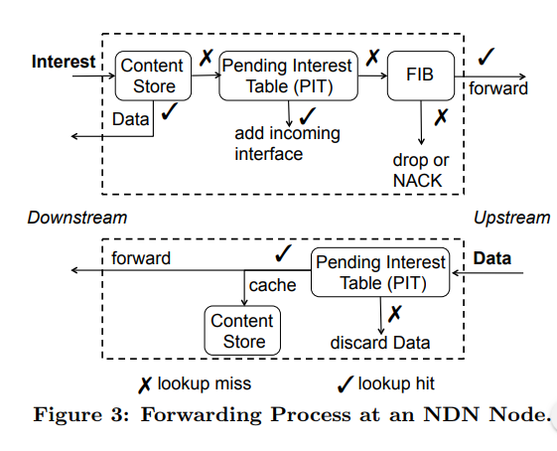 [**Ref**: NDN by Lixia Zhang, Page 02]

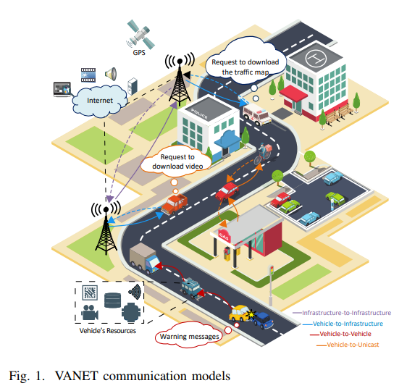

**[Ref:** NDN in Vehicular Ad hoc Networks: State-of-the-Art and Challenges by Hakima Khelifi, PAGE No. 04**]**

**LITERATURE SURVEY**

|  |  |  |  |
| --- | --- | --- | --- |
| **SL No.** | **Paper and Author Details** | **Findings** | **Relevance to the Project** |
| **1.** | NDN by Lixia Zhang,Alexander Afanasyev,Jeffrey Burke,Van Jacobson,kc claffy,Patrick Crowley,St. Louis,Christos Papadopoulos,Lan Wang,Beichuan Zhang | * Introduction to NDN * NDN Architecture * Routing and Forwarding * Caching | Enhancing the knowledge of NDN concept |
| **2.** | Named Data Networking: A survey by Divya Saxenaa, Vaskar Raychoudhurya, Neeraj Surib, Christian Beckerc,Jiannong Caod | * Use of NDN in different technological areas | Application of NDN in vehicular sensor network |
| **3.** | NDN in Vehicular Ad hoc Networks: State-of-the-Art and Challenges by Hakima Khelifi, Senlin Luo, Boubakr Nour, Hassine Moungla, Yasir Faheem, Rasheed Hussain and Adlen | * Introduction to vehicular sensor network(VaNET) * Challenges and issues of VaNET | * Current Status of Vehicular Sensor network strategies * Challenges and issues of vehicular sensor network |

**PROBLEM DEFINITION**

Traditional IP based network request the host address and the producer address to exchange the content. They do not allow replication during communication or fast data retrieval. It doesn’t have efficient data dissemination. In Vehicular Sensor Network, safety application have stringent requirements for delay quality of service and security. Cooperative collision avoidance, lane changing, information(Speed limit, Work Zone and Closed lane) and emergency warning (accident or road condition warnings) and so for, the information must be received by the driver on time. These requirements are not fulfil by the traditional IP based strategies. In vehicular sensor network we required a very less connection time due to fast speed of vehicle. We also required to take into consideration of connection failure problem.

Existing caching strategies also faces several problems. In Probabilistic caching scheme a non-popular content can be influenced by malicious user to be popular. Cooperative caching scheme doesn’t support Information Centric Network(Violate NDN Primitives). Content Popularity Caching scheme may suffer in case of dynamic content,i.e, content that need to be generated upon request or use once content that cannot be known whether it is popular or not. In Alternative caching it may not support V2V communication.

**SOLUTION**

To remove the shortcomings of the traditional strategies and to remove the redundancy of data we will use learning and cooperative caching. We will use Information Centric network(ICN) strategies(NDN) where we will focus more on data. In ICN strategies data are transferred on the basis of universally unique name rather than the traditional IP based strategies. In order to remove the shortcomings of the existing strategies such as probabilistic,cooperative,content popularity and alternative caching schemes we will use more efficient and effective algorithm which will remove the shortcomings of the above mentioned strategies through NDN.

**OBJECTIVE**

To create Information Centric Network (NDN) based strategy for caching which will be able to handle dynamic content, fast V2V, V2I, V2R, V2U, V2X, V2V data transfer and fast data dissemination and which will be more secure from attacks like DDoS (Distributive Denial of Service) and DoS(Denial of Service) attack (since IP is not used, only the universally unique data name are used).

**PROPOSED METHODOLOGY**

We will use Name Data Network(NDN) to achieve the effective and efficient strategies and we will use ndnSIM, nS3 Simulators to test our strategies.

Following are the simulators that we can use

|  |  |  |  |
| --- | --- | --- | --- |
| Simulators | Pros | Cons | Recommendation |
| ndnSIM | • Open source package.  • Supports Linux and Mac OS platforms.  • Maintains all the basic of NDN protocol operations.  • Ability to use all modules, components, and Net Device of NS3.  • Allows researchers to share and use traffic traces and packets analysis among CCNx and ndnSIM.  • Facilitates network-layer experimentation by use routing, caching, forwarding, and congestion management.  • Can run on top of the link-layer, network-layer,and transport-layer protocols.  • Supports large-scale experiments. | • Limited support on the Windows platform.  • Not support simulation network to connect with NFD and ndn-cxx.  • Memory consumption by simulating large-scale experiments.  • Missing of full backward compatibility of new releases. | • V2X scenarios.  • Info-Traffic application.  • Broadcasting Application. • Mobility scenario.  • Video streaming.  • Network Convergence.  • Caching Effectiveness. |
| OM-NET++, C++ | • Open source package.  • Supports Linux, Mac OS, and Windows platforms.  • Easily to use | • Not supports the basic of NDN protocol operations. • Created manually own methods and functions for NDN. | • Info-Traffic application.  • Mobility scenario. |

**IMPLEMENTATION**

The proposed model is to be implemented on OMNET++ simulator along with SUMO which will be intregated via veins. An OMNeT++ model is built from components (modules) which communicate by exchanging messages. Modules can be nested, that is, several modules can be grouped together to form a compound module. When creating the model, you need to map your system into a hierarchy of communicating modules

We will define the model structure in the NED language. We can edit NED in a text editor or in the graphical editor of the Eclipse-based OMNeT++ Simulation IDE.

The active components of the model (simple modules) have to be programmed in C++, using the simulation kernel and class library.

Simulation of Urban MObility", or "SUMO" for short, is an open source, microscopic, multi-modal traffic simulation. It allows to simulate how a given traffic demand which consists of single vehicles moves through a given road network. SUMO requires configuration files and data files for proper execution. These files can be created and edited with a text editor. To work with the various files needed by SUMO you must be able to find them on your file system. SUMO consists of many separate programs for different simulation-related tasks (a reference to all the seperate programs can be found in SUMO_User_Documentation#Appendices). Only the program sumo-gui.exe SUMO-GUI has a graphical user interface (GUI). All other programs must be called from the command line.

Veins runs on Linux, Mac OS X, and Windows. Because of the extensive debugging capabilities that it offers, Veins is best built and run on Linux.

With the help of veins we can easily capable to integrate omnetpp code in SUMO simulator.

**GANTT CHART**

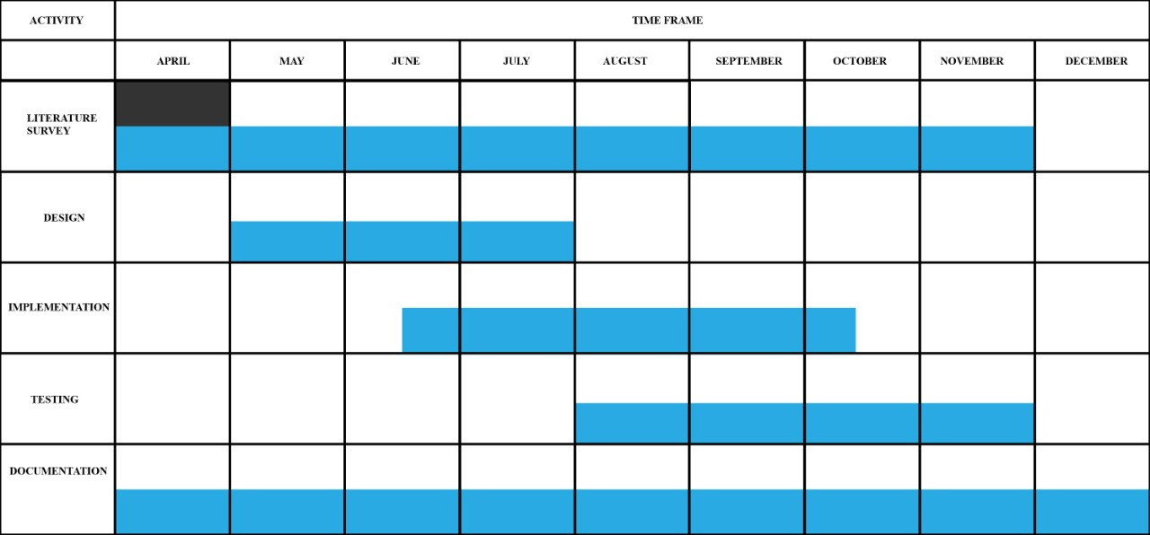

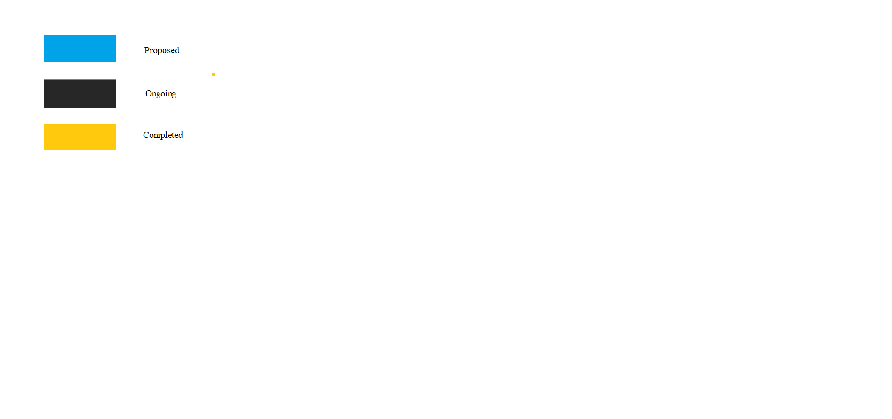

**REFERENCES**

1. Named Data Networking in Vehicular Ad hoc Networks: State-of-the-Art and Challenges by Hakima Khelifi, Senlin Luo, Boubakr Nour, Hassine Moungla, Yasir Faheem, Rasheed Hussain and Adlen Ksentini
2. Named Data Networking by Lixia Zhang,Alexander Afanasyev,Jeffrey Burke,Van Jacobson,kc claffy,Patrick Crowley,St. Louis,Christos Papadopoulos,Lan Wang,Beichuan Zhang
3. Named Data Networking: A survey by Divya Saxenaa, Vaskar Raychoudhurya, Neeraj Surib, Christian Beckerc,Jiannong Caod